Recognized Rabbit Breeds
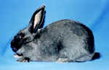 | 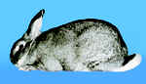 | 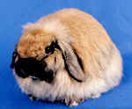 | 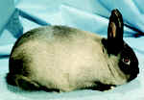
American  Max. weight - 12 pounds | American Chinchilla  Max. weight - 12 pounds | American Fuzzy Lop  Max. weight - 4 pounds | American Sable  Max. weight - 10 pounds
. | . | . | .
 | 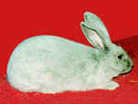 | 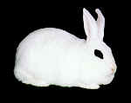 | 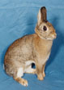
Belgian Hare  Max. weight - 9 1/2 pounds | Beveren  Max. weight - 12 pounds | Blanc de Hotot  Max. weight - 11 pounds | Britannia Petite  Max. weight - 2 1/2 pounds
. | . | . | .
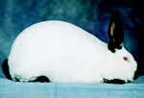 | 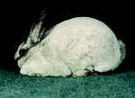 | 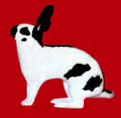 | 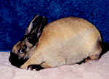
Californian  Max. weight - 10 1/2 pounds | Champagne d'Argent  Max.. weight - 12 pounds | Checkered Giant  Max. weight - none | Cinnamon  Max. weight - 11 pounds
. | . | . | .
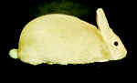 | 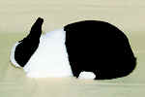 | 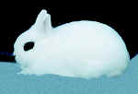 | 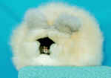
Creme d'Argent  Max. weight - 11 pounds | Dutch  Max.. weight - 5 1/2 pounds | Dwarf Hotot  Max. weight - 3 pounds | English Angora  Max. weight - 7 1/2 pounds
. | . | . | .
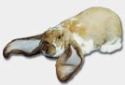 | 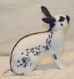 | 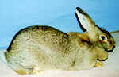 | 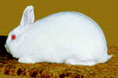
English Lop  Max. weight - none | English Spot  Max.. weight - 8 pounds | Flemish Giant  Max. weight - none | Florida White  Max. weight - 6 pounds
. | . | . | .
. | . | . | .
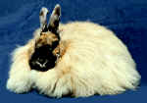 | 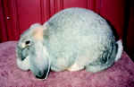 | 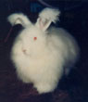 | 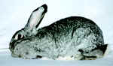
French Angora  Max. weight - 10 1/2 pounds | French Lop  Max.. weight - none | Giant Angora  Max. weight - none | Giant Chinchilla  Max. weight - 16 pounds
. | . | . | .
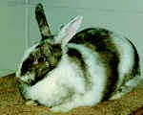 |  |  | 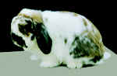
Harlequin  Max. weight - 9 1/2 pounds | Havana  Max.. weight - 6 1/2 pounds | Himalayan  Max. weight - 4 1/2 pounds | Holland Lop  Max. weight - 4 pounds
. | . | . | .
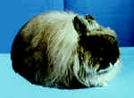 | 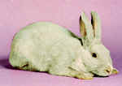 | 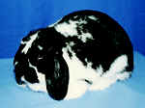 | 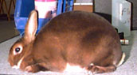
Jersey Wooly  Max. weight - 3 1/2 pounds | Lilac  Max.. weight - 8 pounds | Mini Lop  Max. weight - 6 1/2 pounds | Mini Rex  Max. weight - 4 1/2 pounds
. | . | . | .
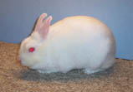 | 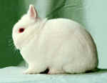 | 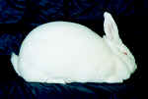 | 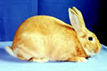
Mini Satin  Max. weight - 4 3/4 pounds | Netherland Dwarf  Max.. weight - 2 1/2 pounds | New Zealand  Max. weight - 12 pounds | Palomino  Max. weight - 11 pounds
. | . | . | .
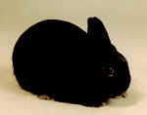 | 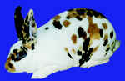 | 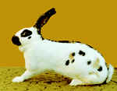
Polish  Max. weight - 3 1/2 pounds | Rex  Max.. weight - 10 1/2 pounds | Rhinelander  Max. weight - 10 pounds | Satin  Max. weight - 11 pounds
. | . | . | .
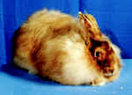 | 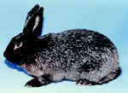 | 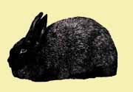 | 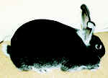
Satin Angora  Max. weight - 9 1/2 pounds | Silver  Max.. weight - 7 pounds | Silver Fox  Max. weight - 12 pounds | Silver Marten  Max. weight - 9 1/2 pounds
. | . | . | .
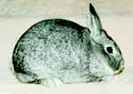 | 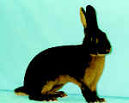 | 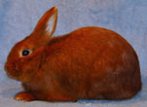
Standard Chinchilla  Max. weight - 7 1/2 pounds | Tan  Max. weight - 6 pounds | Thrianta  Max.. weight - 6 pounds
. | . | . | .

