Supplies Checklist
____ Lone Star Pellets (specifically ask for at handleys)
____ Water Bucket
____ Water Rope/Leash
____ Food Bag ( Show Rite is good to start with)
____ Food Scoop ( 2 quart scoop )
____ Rope Halter
____ Goat coat ( depending on goats size medium is a good start for most )
____ Hay
____ Fly Strips
Lone Star Pellets
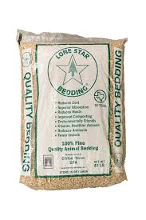
-In my opinion this bedding spreads the most evenly and is the best at absorbing urine and feces
Water Bucket
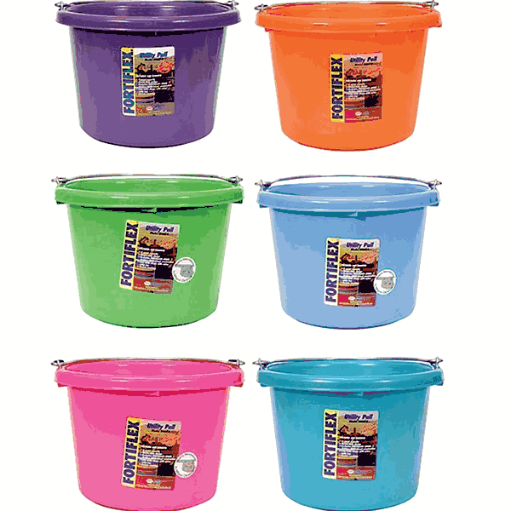
-An 8 quart bucket will hold the correct amount of water for the day
-The bucket must be cleaned daily, as bugs, dirt and even feces will fall in during the course of the day
Water Rope/ Leash
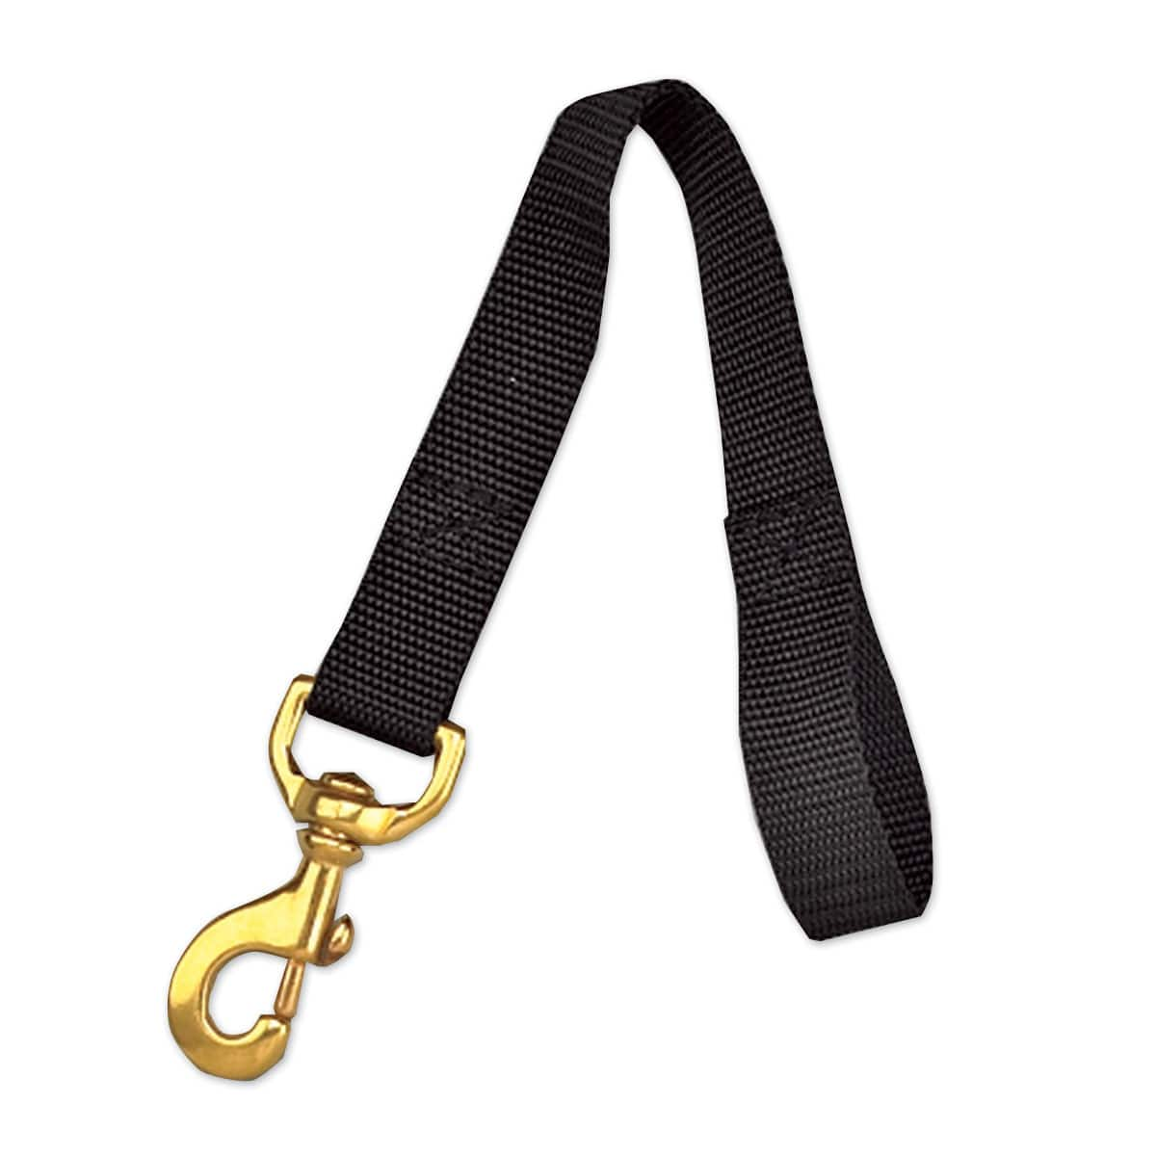
-You’ll use this to secure your water bucket to the side of your pin and keep your goat from knocking it over.
Food
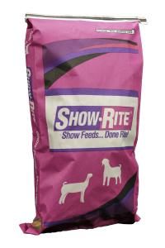
-For the first few weeks you’ll feed your goat Show-Rite Goat Advancer feed
-Later your advisor may recommend another feed, do as they recommend

Food Scoop
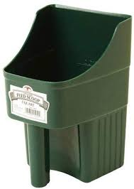
-While there are other types of food scoop, I find this one makes it easiest to hold your food and mix in any supplements your advisor may recommend
Rope Halter
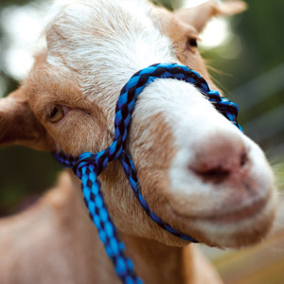
-These are used to walk your animal, but not to show them
-Ask your advisor or an upperclassman to show you the correct way to put it on
Goat Coat
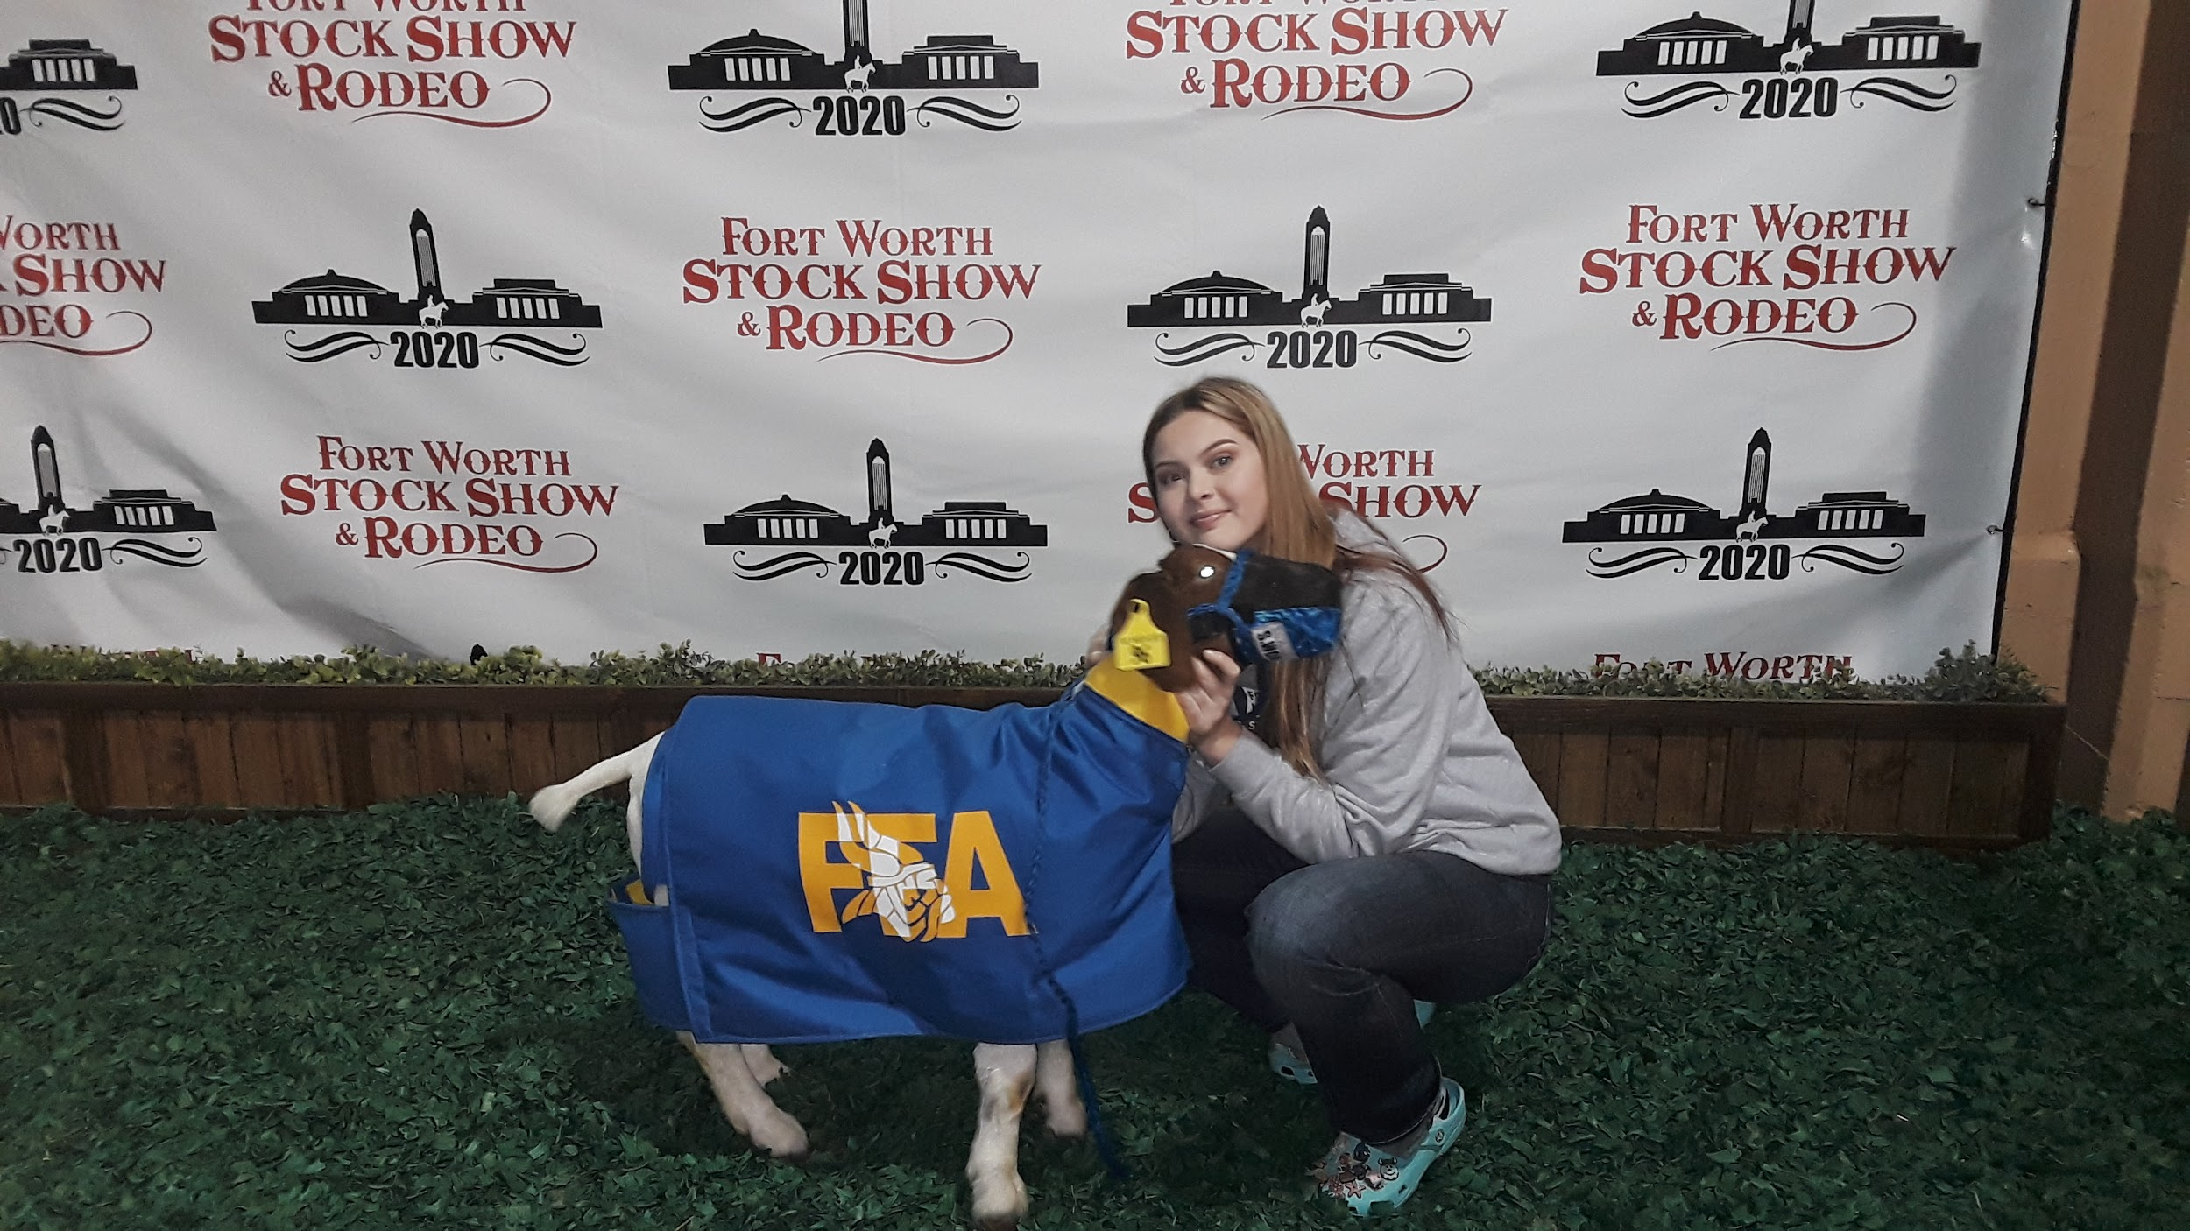
-The advisors will ask you to put a coat on your goat when the weather begins to get cold, get ahead of the game and get one early
Hay
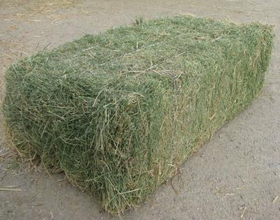
-We feed our goats alfalfa hay and sometimes Coastal Grass hay
Fly Strips
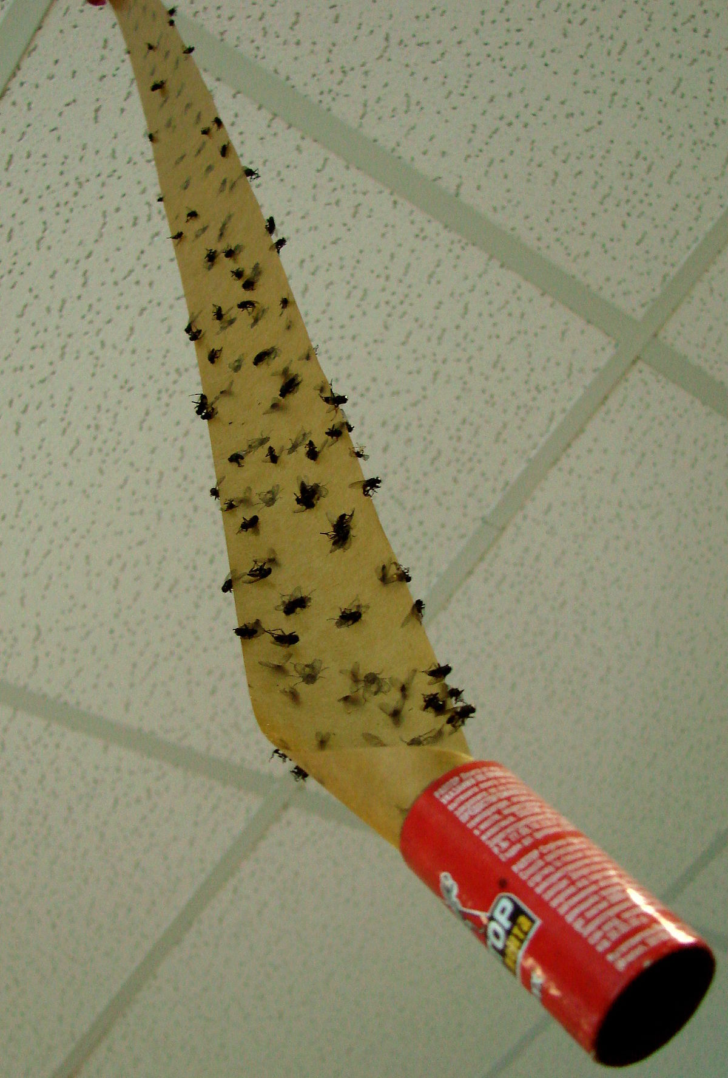
-Due to all the animals there are lots of flies in the barn, putting up fly strips will make them much more manageable in your area

Showtime Essentials
____ Show Halter
____ Show Collar
____ Drenching Gun
____ Gold Dust (you also might want to get a cup or container to mix in)
____ Bag of Feed ( most the time )
____ Show Clothes
____ Show Shoes
____ Muzzle

Show Halter
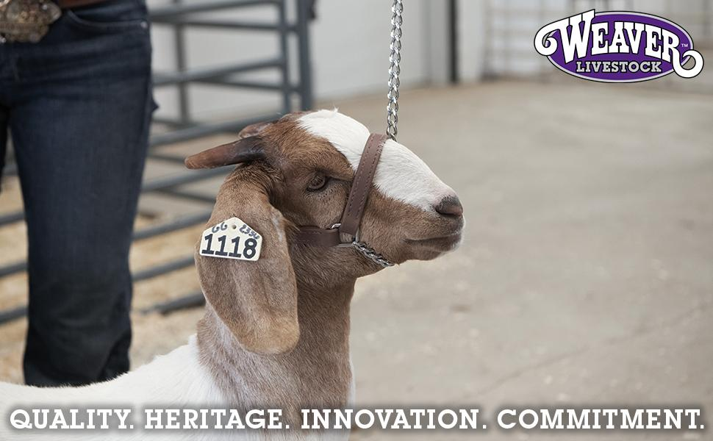
-A show halter is used to hold your goat’s head in place to make them look good while walking
Show Collar
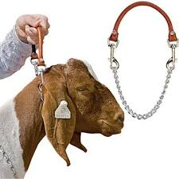
-A show collar is used to hold your goat’s head in place and make them look good while walking

Drenching Gun
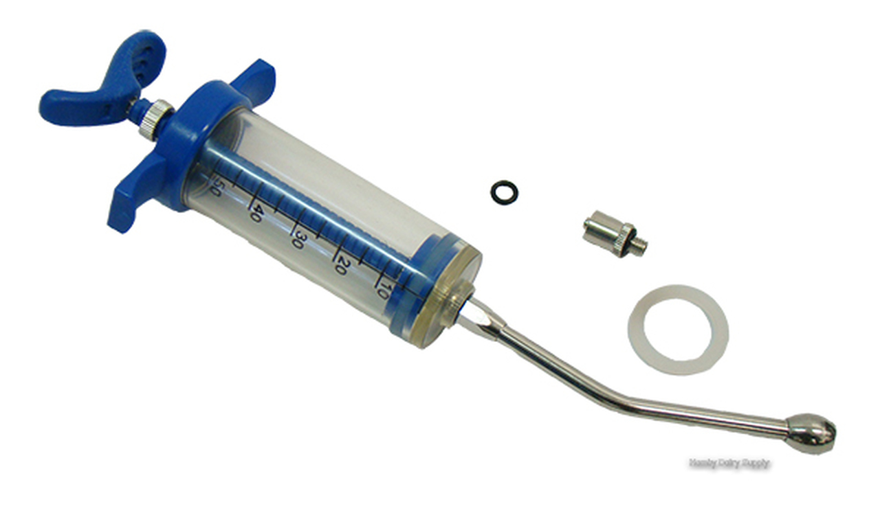
-Used to hydrate your goat on show day
Gold Dust
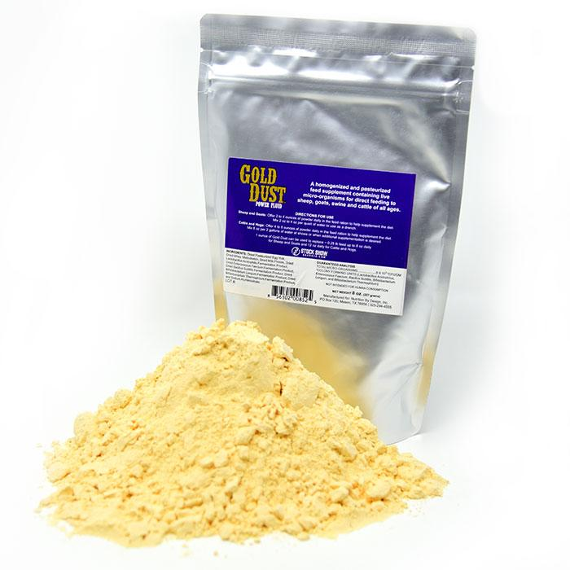
-Gold dust is used to help bulk your goat and can be bought online or at stock shows
-It is administered through drenching
-Only use gold dust if suggested by your advisor
Bag of Feed
-Depending on when you’re showing you may need to take a day’s feed with you in a gallon bag

Show Clothes
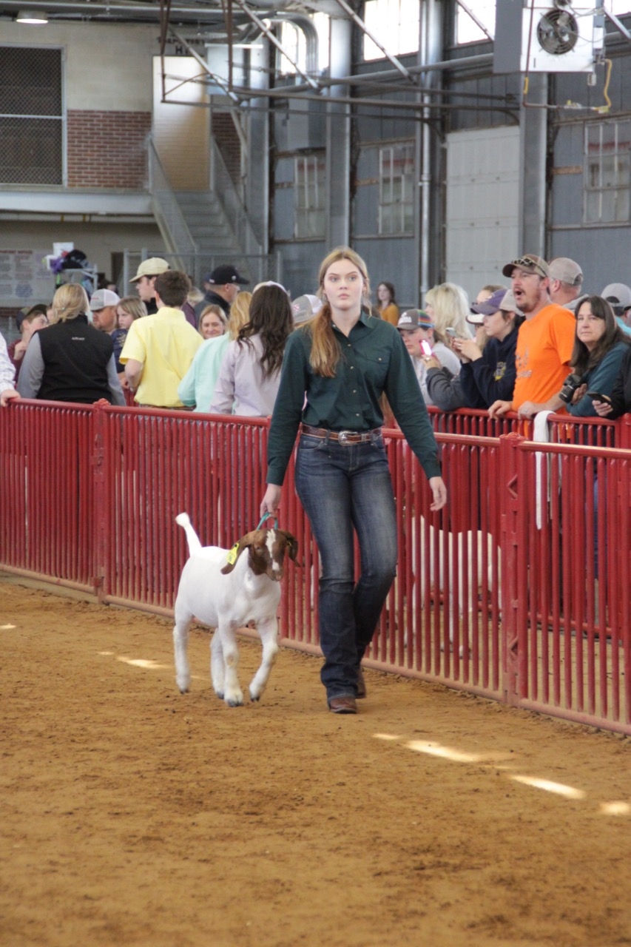
-Long sleeved button up shirt
-Belt
-Plain jeans (no skinny jeans, no holes)
Show Shoes
-These will typically be cowboy boots or “Twisted X”
Goat Muzzle
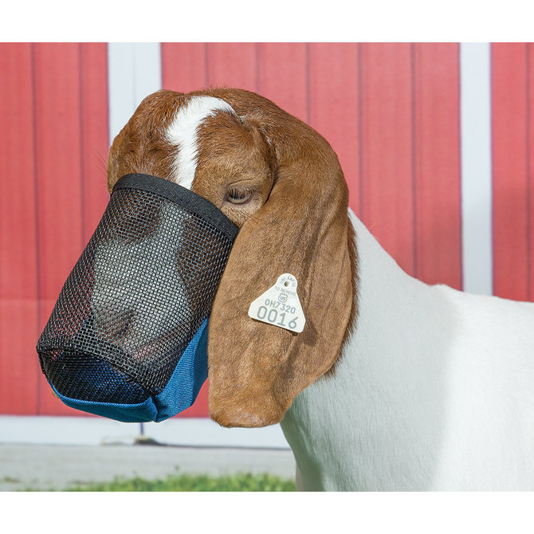
-Slightly smaller than lamb muzzles
-Used to keep your goat from eating the bedding at shows

