Arlington FFA August & September Newsletter

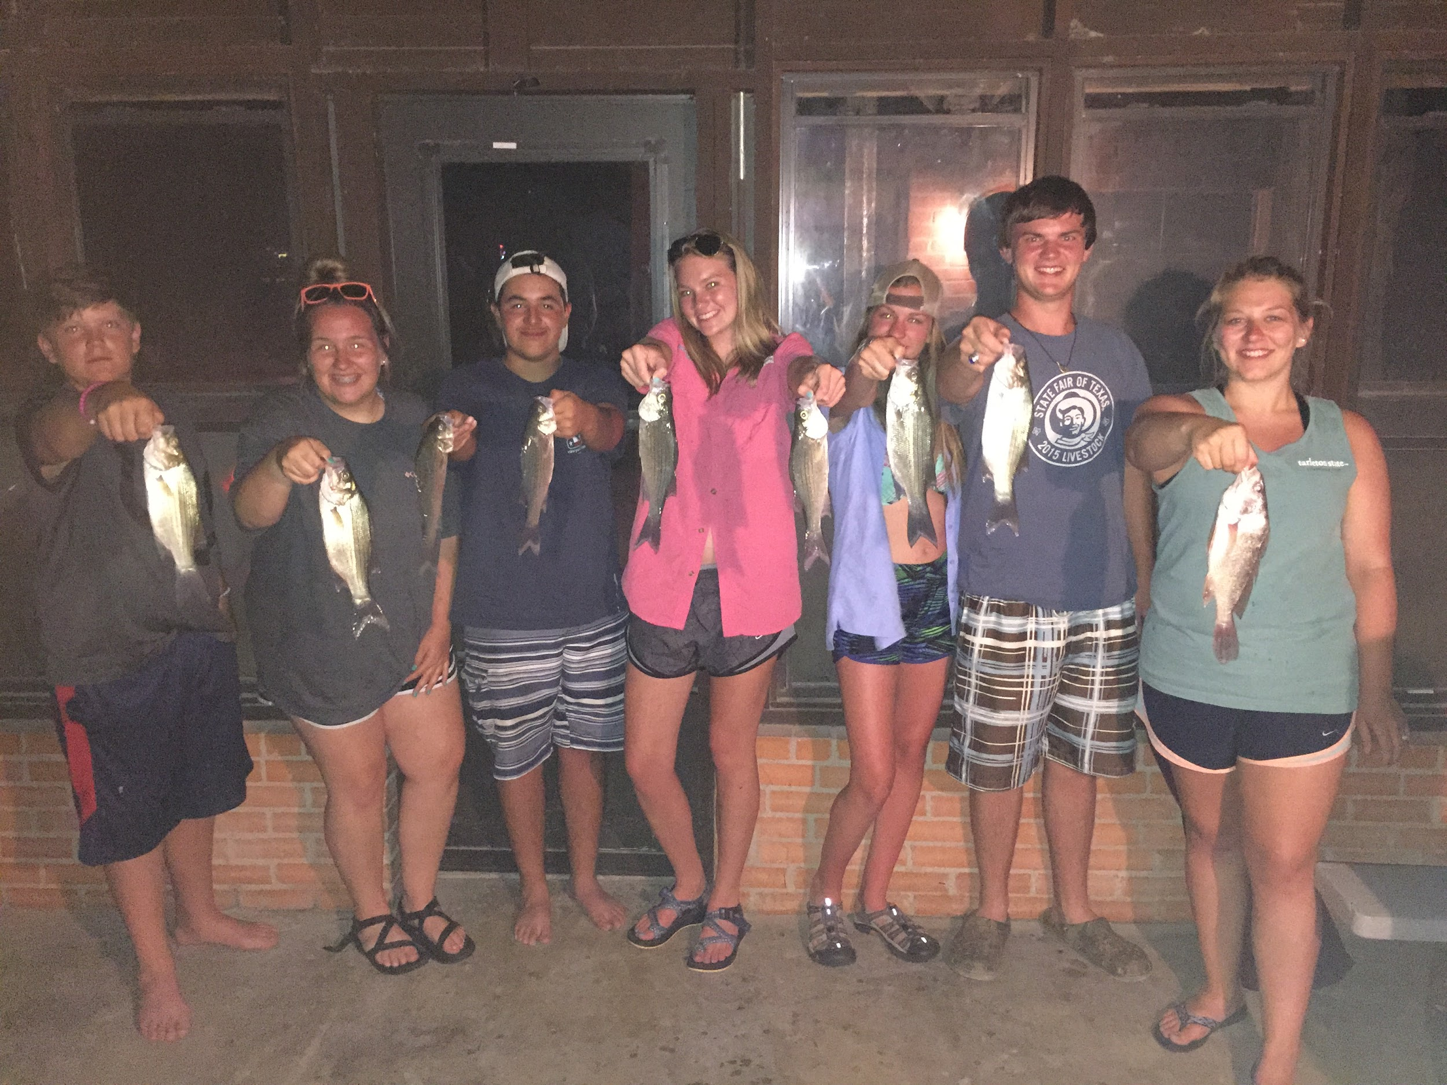
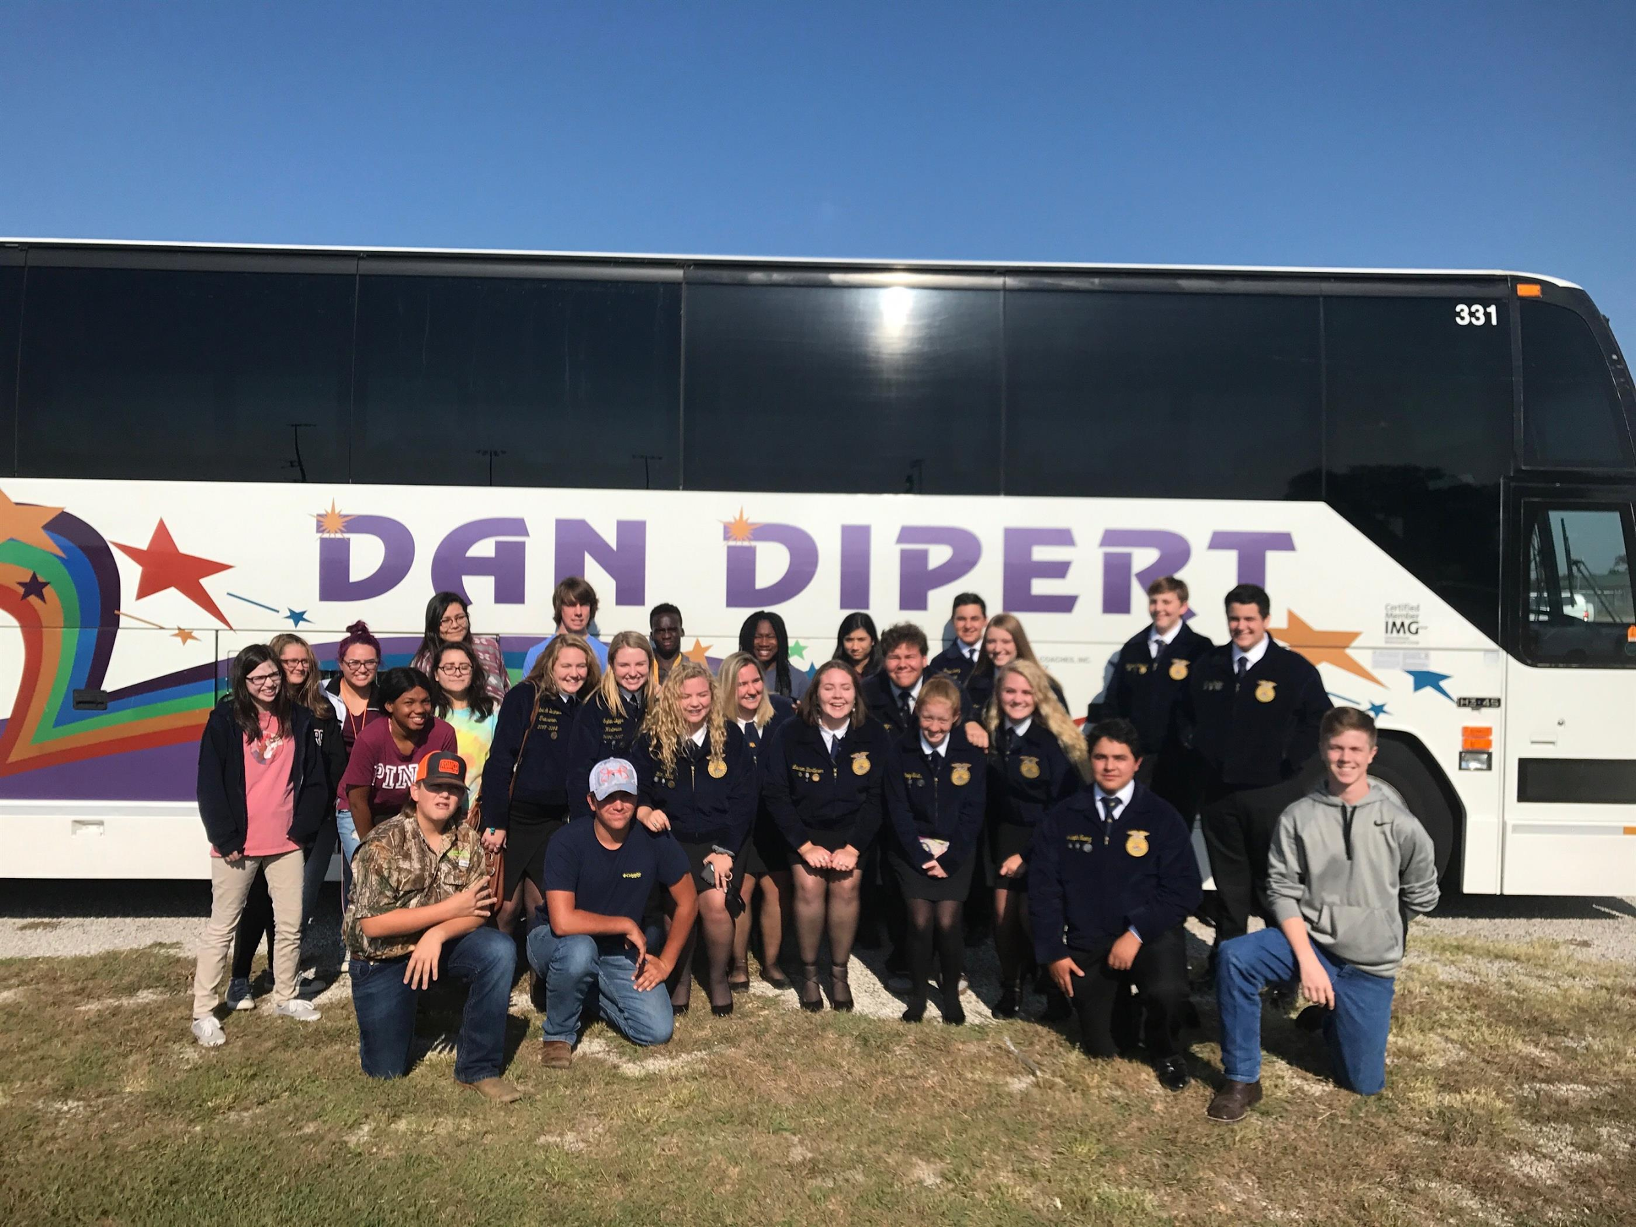
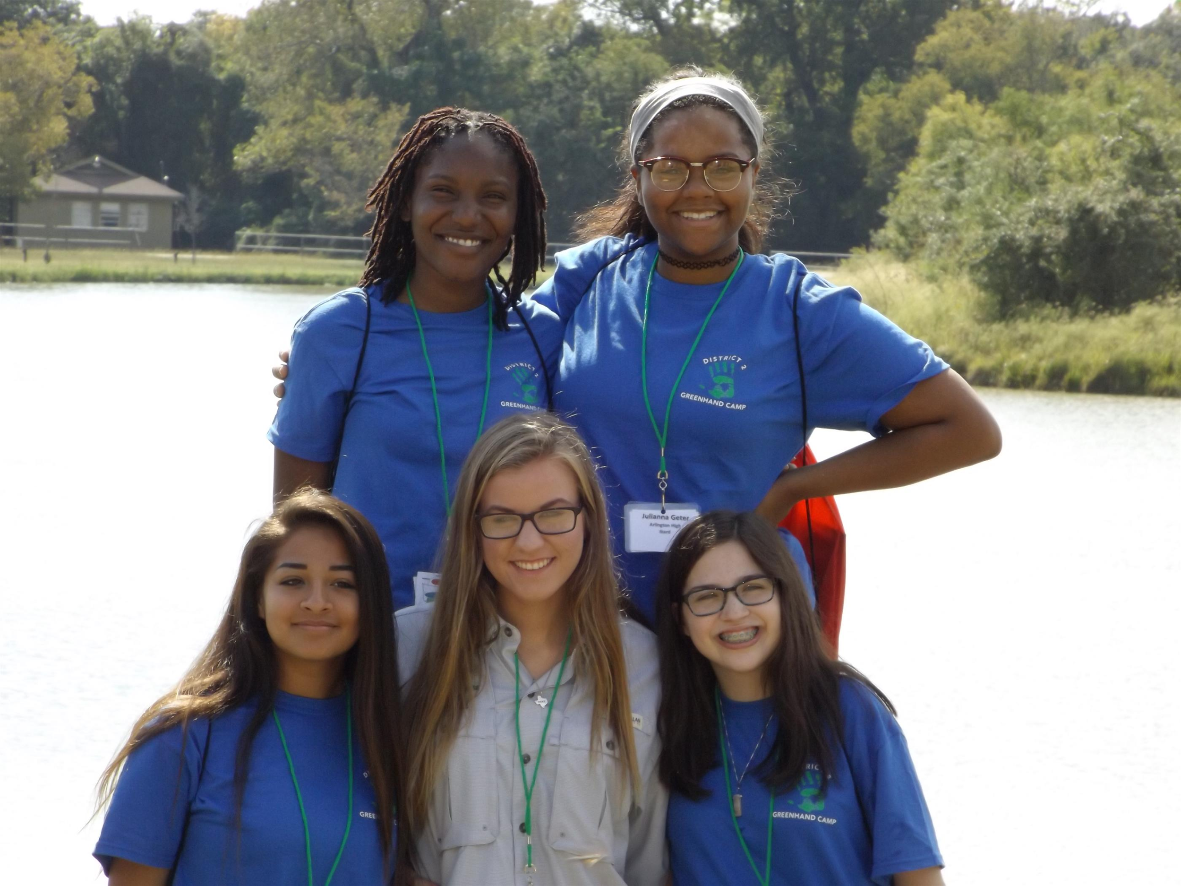
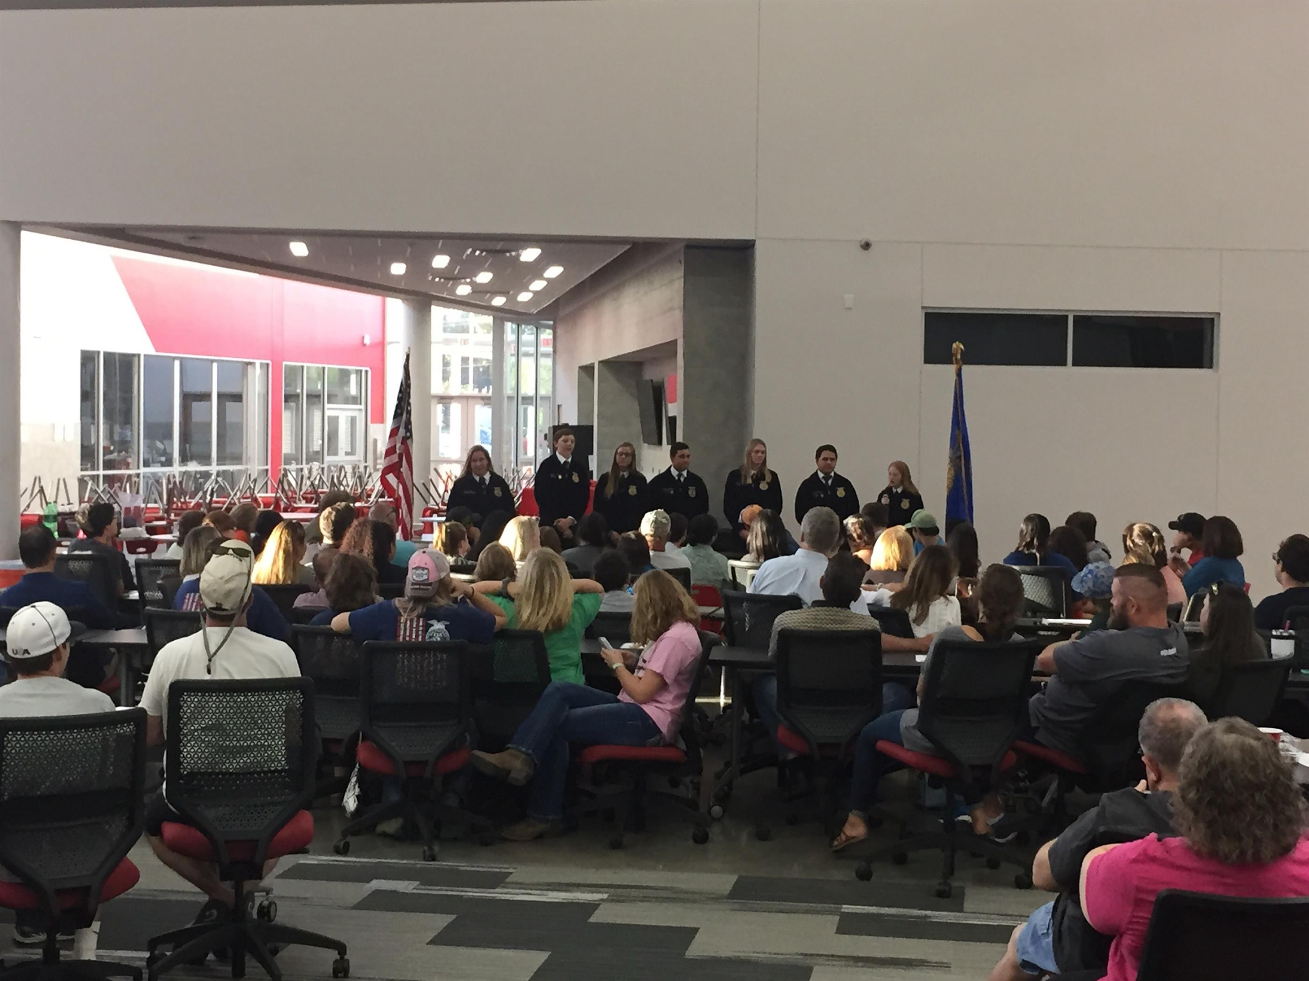
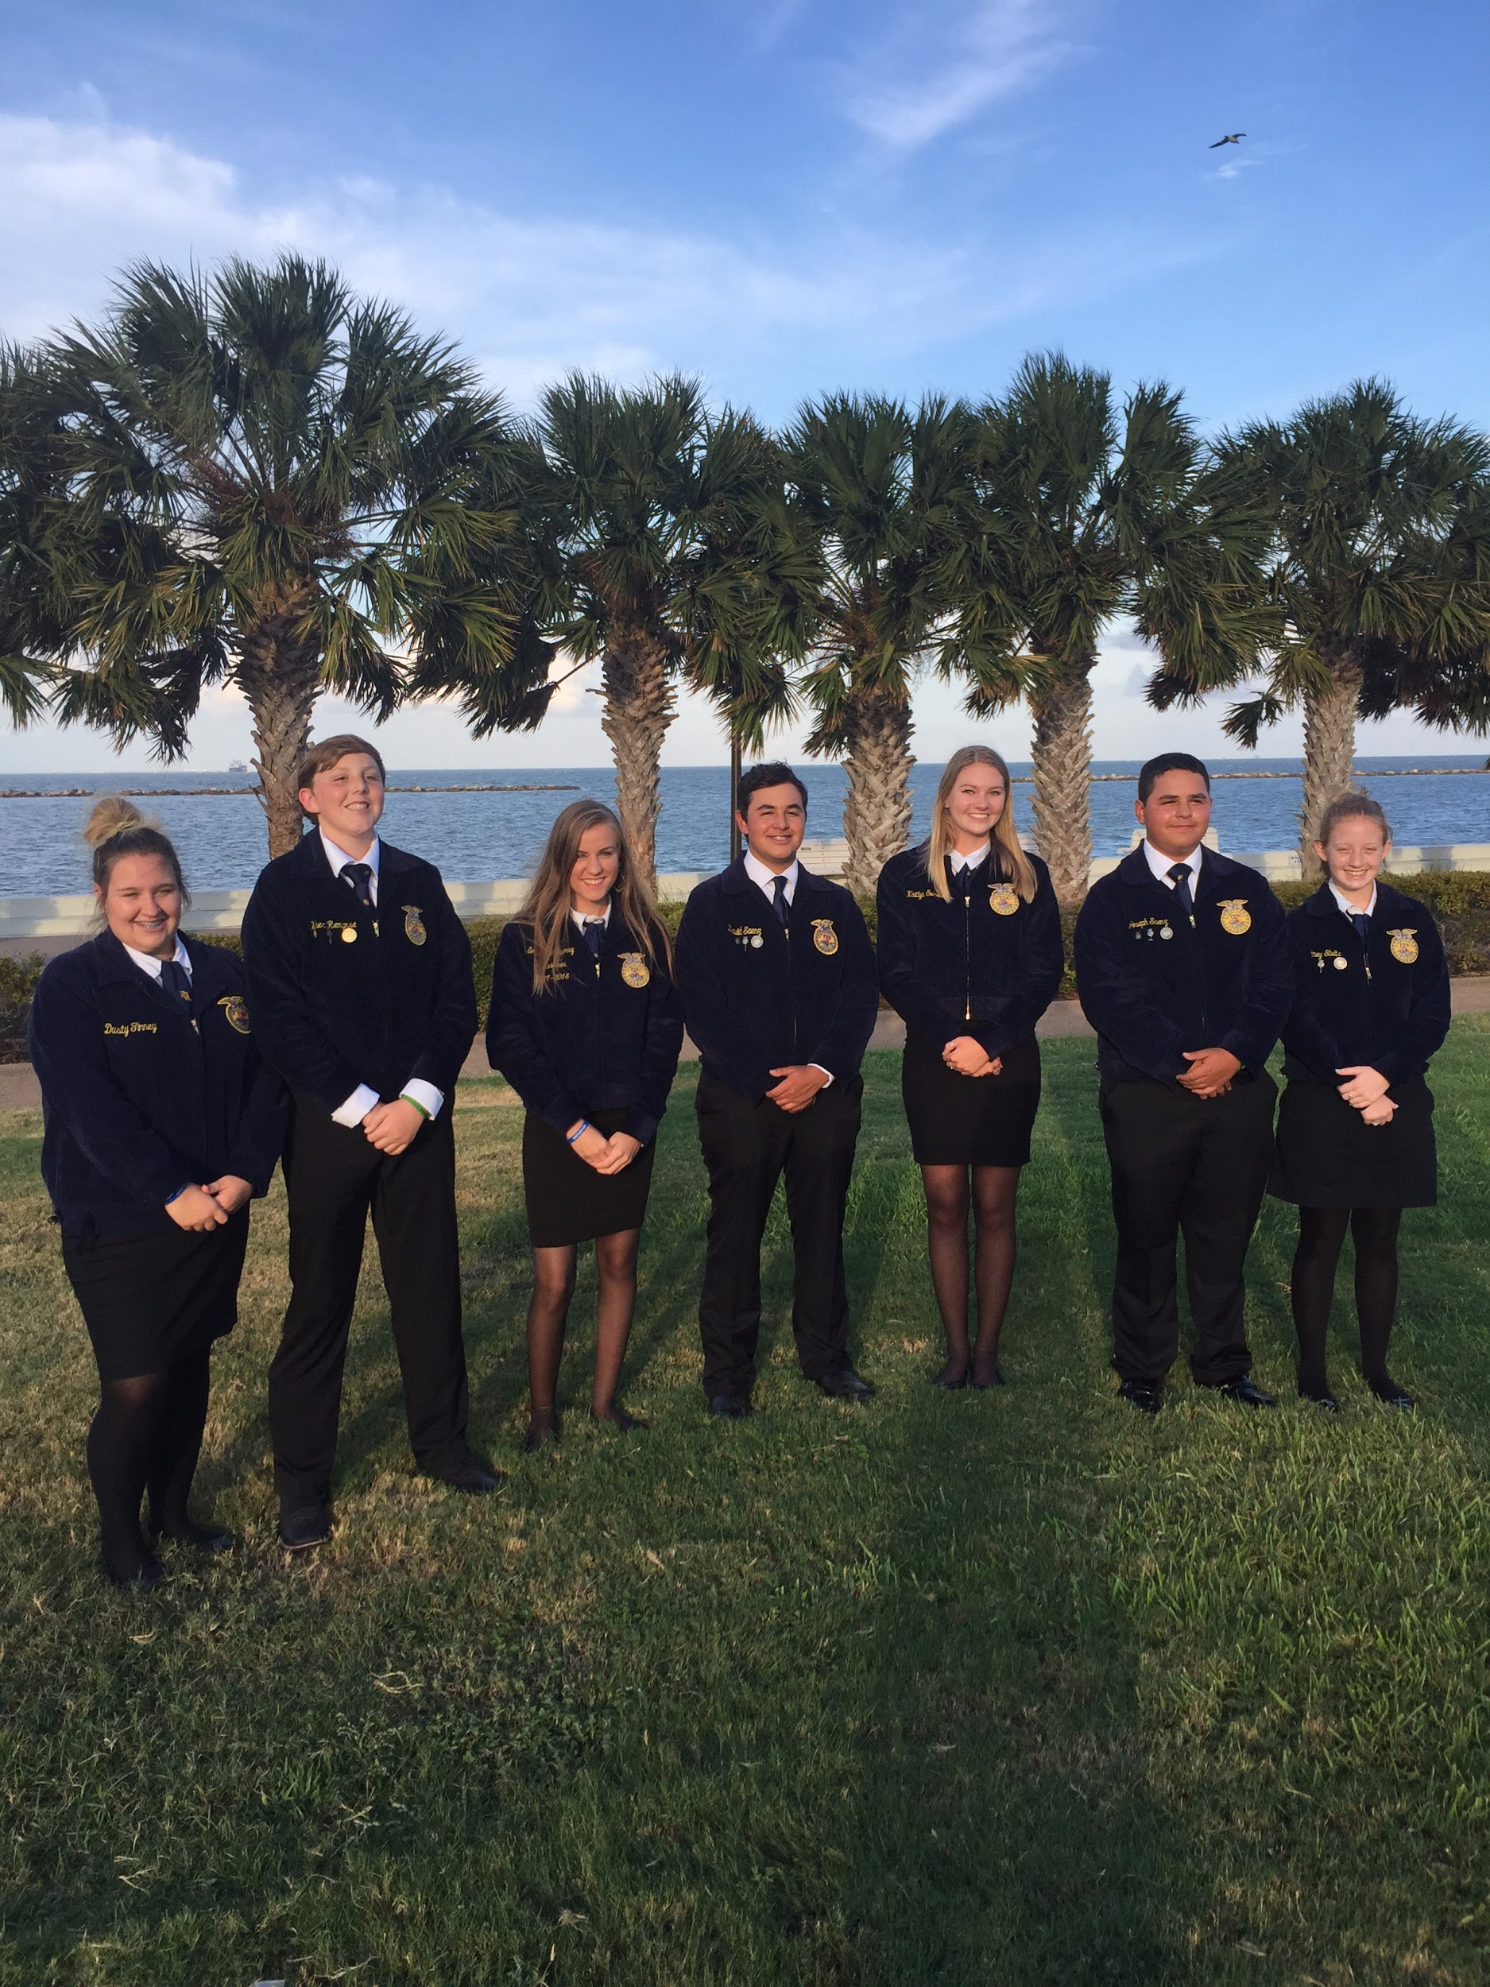
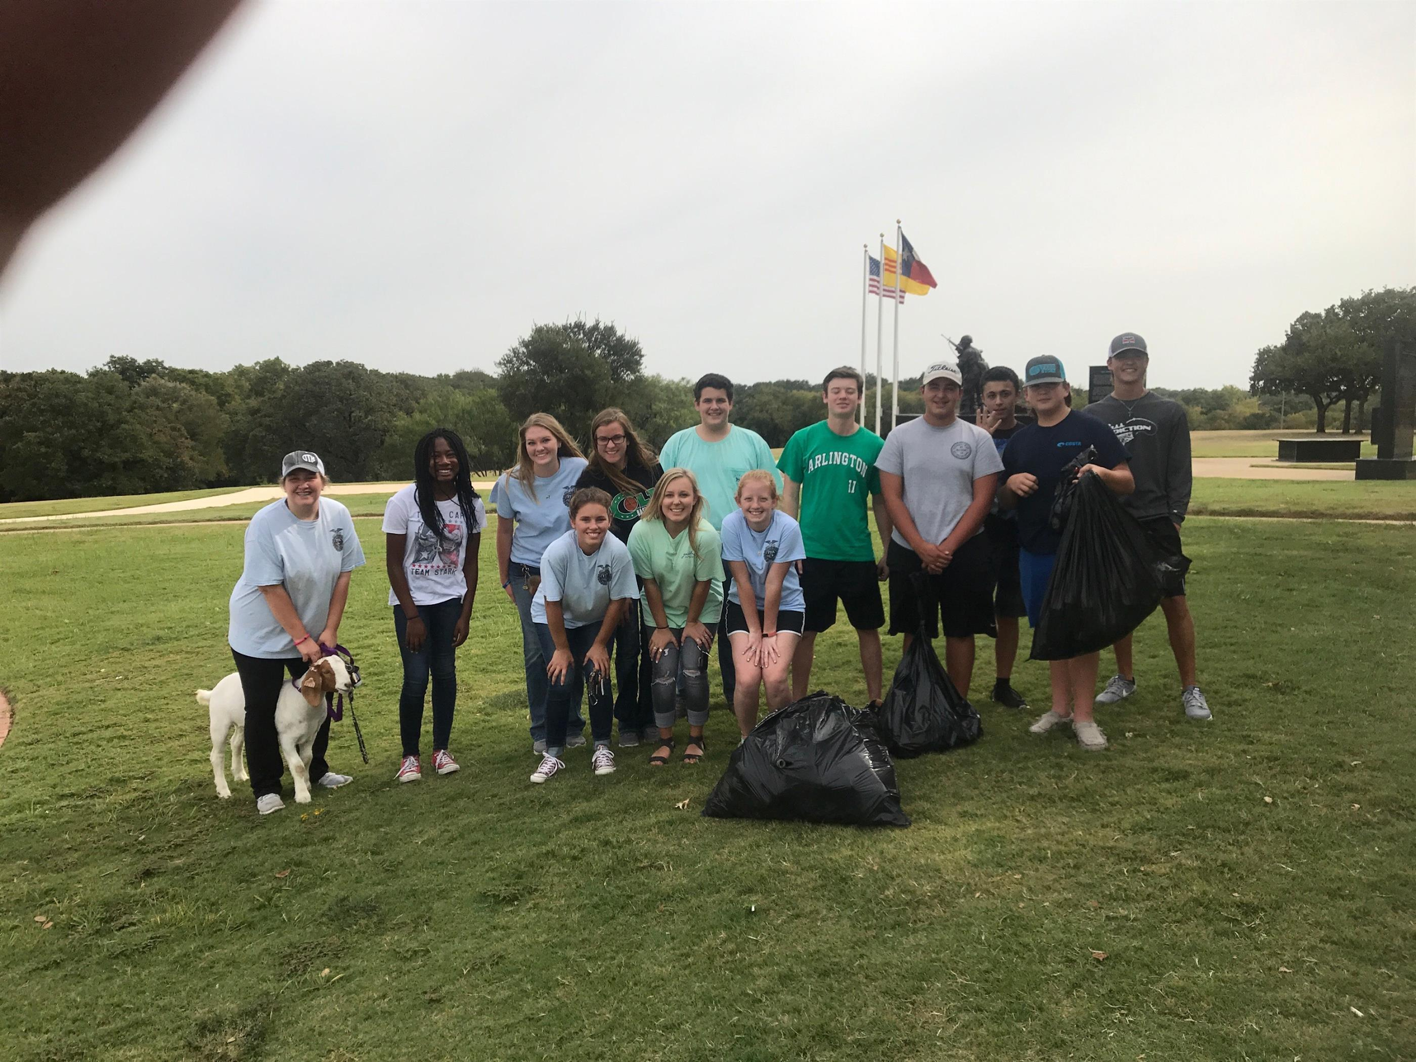
Welcome back to school AHS! At the beginning of the summer we had our FFA fishing trip. It was super fun, and we had the opportunity to get closer as a chapter. To start off this school year, in August, the Arlington FFA officers attended the 89th Texas State FFA Convention in Corpus Christi , Texas. They also had an officer retreat at Lake Whitney to plan chapter meetings, assume officer responsibilities, and to team build. We also walked in the Arlington High School homecoming red wagon parade with our senior officers- Dusty Tinney and David Saenz- pulling a goat through the gym. In September, we had events such as the Annual Ice Cream Social and Parent Livestock meeting. We went over information about what FFA is, and details about showing livestock. This meeting was held in the brand new CTC building. It was so much fun meeting all the new members, and we had a great turn out. The District 2 meeting on Monday the 11th invited both old and new members to a more formal meeting at Peaster High School in Peaster, Texas. The meeting was full of fun and games. On Tuesday the 12th, we began our very first 10 on Tuesday of the year at Veterans Park. 10 on Tuesday is a movement to help clean up our communities and prevent litter from clogging pipes and polluting our waters. We just recently started our annual Seitz meat fundraiser on the 18th. We sell the most delicious and fresh meat products! We are the only AHS organization that sells high quality agriculture based food products. With the holiday season coming up, this is an awesome opportunity to get gifts for your “meat-loving” loved ones. You can talk to an Ag student about products and prices. Thursday the 21nd, we had our Parent/Alumni softball game. It was so much fun seeing old faces, and getting to play a little softball. On the 24th and 25th, new FFA members went to Greenhand camp. They learned about parliamentary procedure, various leadership skills, and completed many team building exercises, while also building new friendships.

Upcoming Events:
On the 3rd of October, we will be taking a select number of students interested in showing a goat this year to go and pick out and buy a goat. On the 10th of October, we will be having a rabbit showmanship clinic for any students planning on showing a rabbit this year. On the 17th, we are having another 10 on Tuesday. This will be located at Mary and Jimmie Hooper Park. On October 24th is state goat and heifer validations for all students that are showing a heifer or goat this year. We also have an upcoming Halloween Party on October 26th at 6:30. This will be held at the new Ag Barn. Wear your best costume for the costume contest and be prepared to have fun! On November 2nd, we have a mandatory parent meeting for livestock shows at 6:30 at the new ag barn off of Pioneer. Our first LDE competition of the year will be on the 6th of November in Springtown. We will be leaving the ag barn in Official Dress at 3:30 pm and will be arriving back around 9:00pm. Students will need to bring $5.00 for pizza. Students can sign up in their Ag classes. On the 8th and the 14th, we will be going to Mission Arlington to do some community service. And on the 16th, we will be having our softball game against Martin at 6:30.
Lastly, please stay connected with Arlington FFA. Whether it is on social media, enrolling in our Remind program or signing up to receive our newsletter. We want to make sure no one is left out, and to keep everyone informed. Just text 817-442-3296 with the message: @d009f to receive reminders about meetings and events. You can also visit our Parents Tab on our website. Let’s make this a great year!!
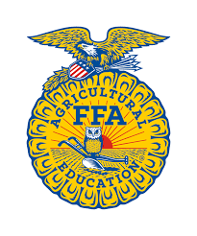
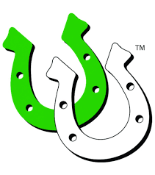
Twitter: @AtownFFA
Instagram: @arlington_ffa
Facebook: @AginAggTown
Website: arlington.ffanow.org

