It's Show Time !!!!

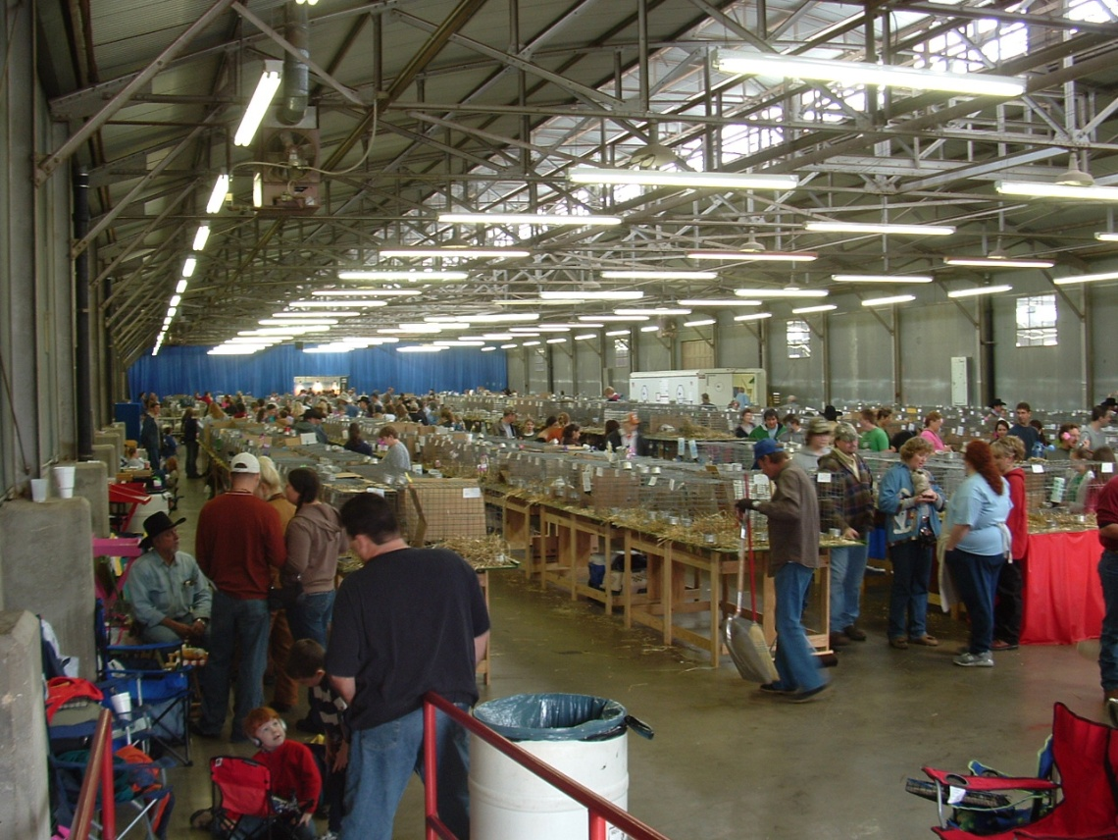

Breeding Rabbit Show Guide

What is a Rabbit Show?
If it is a Saturday or Sunday, chances are you can find a rabbit show somewhere in the United States. In California alone, there are over 100 rabbit shows each year. Most Rabbit Clubs will schedule two shows on the same day which allows each Rabbit Class to be judged by two separate judges. Rabbit owners will exchange bunny stories, tips, make friends, buy and sell bunnies, compete and improve breeds. Most local shows have several hundred to several thousand rabbits. National conventions usually have more than 10,000.
What rabbits can I show?
The American Rabbit Breeders Association (ARBA) encourages the showing of purebred and pedigreed rabbits, but rabbits do not have to be purebred or pedigreed to be shown. A casual show exhibitor can have as much fun in a rabbit show as a serious competitor.
How Are Rabbits Judged?
The standard for judging rabbits is the "Standard of Perfection," which is published by ARBA. It is revised every 5 years to reflect any changes and new varieties. The Standard of Perfection lists 45 accepted breeds. Each breed has a different point distribution on different parts of the rabbit: The judges use this point system to judge each rabbit. Some breeds ask for the overall body to be short, some breeds want the body to be medium length and some long. The judges must be familiar with each breed to know how to place the rabbits.
Who are the judges?
Only ARBA licensed judges can officiate in an ARBA sanctioned show. Each potential judge has to pass a written test and then apprentice under licensed judges for several shows to be eligible to apply for a license.
What are the prizes?
There are very few monetary rewards. Most prizes are trophies and ribbons. If the first place rabbit is chosen from at least five rabbits exhibited by three owners, this rabbit wins a "leg." If a rabbit wins three legs in at least three shows judged by at least two different judges, and the rabbit is registered, this rabbit qualifies to apply for a grand champion status from ARBA..
How much are the show entry fees?
Entering a rabbit show is very affordable for an individual or family. The entry fee is typically $3.00 - $4.00 per animal. Most shows are free to attend.
How do I enter a show?
Most rabbit clubs prepare and distribute their catalogs approximately a month before the show. To obtain an entry form, download the show catalog from our home page or contact the show secretary and request one. Complete the entry form by listing each animal you are entering with its ear number, breed, variety, sex and age. Once the form is done, send the form in with the entry fee. Be sure to note the entry deadline date.
What is rabbit showmanship?
It's not always just about the rabbit. Rabbit Showmanship is an important part of showing your rabbit. In showmanship, you compete against other rabbit owners and prove how well you handle and know your rabbit. The procedure should be part of your routine to ensure your herd is healthy and stays healthy.

Rabbit Show Basics
Before you try to show rabbits, I urge you to purchase the American Rabbit Breeders Association (ARBA) Standard of Perfection--read it and study the standard or sometimes you can find this information on the internet searching for your specific breed. The standard has information on the qualities that your rabbit will be judged upon. You have to know all the terms that the standard covers as well as learn what would be a disqualification or an elimination, what colors and body type is correct for your breed, etc. You should know as much as you can about rabbits to show them well, and knowing the breed standard by heart is a very wise idea. Otherwise, if you have a disqualified animal, for example, and try showing it, you've just wasted your entry fee.
Any rabbit being shown must have a legible ear tattoo in the left ear. If you do not have your rabbit tattooed, you will probably be able to find someone to do it for you if you know where to look. A good place to start looking is with your local rabbit club--someone who has a tattoo set might be willing to do it for you. You can also look for a judge or registrar (there are registrars at rabbit shows), but they might charge you for the service. What to tattoo is up to you--it can be any combination of letters or numbers, as there is no rule regarding the tattoo (other than it must be legible and in the left ear).

Finding and Entering Shows
Locate a rabbit show that you'd like to attend by visiting the ARBA site or at bunnyrabbit.com has a link that you can click on for a list of local shows. Once you've found a show, contact the show secretary and request a show catalog. The show catalog will give you all the pertinent info about the show--when the show is, how much entry fees are, who is judging, the check-in time, what time the show starts, where the show is, what the show rules are, etc.
After you get the catalog, fill out the entry form and mail it in by the deadline with the entry fee to the address listed. Some shows require a pre-entry--you have to send it in by the deadline or your money will be sent back and you will not be allowed to enter.
If the show is a "day-of-entry" show, you simply pay your fee and do all the paperwork the day of the show. If you do this, be sure to arrive at least an hour ahead of show time to get in line. It will be crowded and hard to find a parking space if you do not get their early. Most of the shows that I have been to are “day of entry” shows. You might be able to send in your paperwork and fees ahead of time. If the catalog does not have an entry form, you will be able to get it at the show (day-of-entry shows will have all paperwork you need). If you have any questions about the paperwork, ask someone--they will be happy to help you fill it out correctly.
Be very cautious when filling out the paperwork. All information must match on the entry form and the remark cards. If you "scratch" an animal (remove it), you might be able to substitute another. In most cases the substitution must be in the same breed, variety, sex and class. Check with the show secretary for details. To make it easy because you have to fill out an entry form for each rabbit for each show they are entered. We made 2x2” labels to put on these forms with the required information. Saves the hands from getting all cramped up!!!! Below is a sample of these labels:

Ear No. CL Entry No. ________
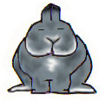
Caitlin M. Eaton
6203 Lemesa Court
Arlington, Tx 76016
Show__________ Date ________
Netherland Dwarf Chinchilla Senior Buck

The Showroom

How Do I Take My Rabbit to a Show?
Rabbits are taken to the shows in their show Carriers – small wire cages with pans. Carriers are available in pet stores, feed stores and through mail-order companies. At most shows, there will be vendors there that sell all matter of things that you could possiably need. The pan should have a material to absorb wastes. If you show shorthair breeds, shavings, hay, kitty litter and newspaper are all acceptable. If you show longhair (wool) breeds, only flat newspaper is recommended. Other material will stick to the rabbits' wool and make a mess for the owner to clean. If you are going to a show that lasts more than one day, make sure that all lining materials are changed daily.
Arrival at the Show
The show superintendent and/or show committee will put a list of breeds together. Usually certain breeds (ones that tend to have a large number of entries) will start first. If you have one of those breeds, you must enter on time--if you enter late, you are out of luck.
Leave early so you have plenty of time--if you get there too late and the show has already started--too bad. When you arrive at the show, leave the animals in the car if weather permits, and find the entry booth. Fill out your paperwork, pay your fees, and walk around the showroom. Usually there will be several long tables set up, and a posting of the breeds and the judge's name will be available by each table.
Locate where your breed is going to be judged, and go fetch your rabbit(s). Set up as close to the table where your breed will be shown as possible because you have to be paying attention and carry your animals up to the table when your entry is called. Try not to have a leaky carrier, and if your rabbit makes a mess please clean it up!
Now you wait. Pack a comfortable lawn chair, take a book or something to do, and pack a cooler with snacks, lunch and plenty of drinks. You can buy this stuff at the show, but it is a little expensive.
Wear comfortable clothes, comfortable and sturdy walking shoes, and bring a blanket and or jacket/sweater. If you have a breed that is a bit further down the list--you might have several hours to kill, so you can walk around, watch and listen to the judging, talk to breeders, visit the vendors, or take a nap because you got up before the birds to do this.
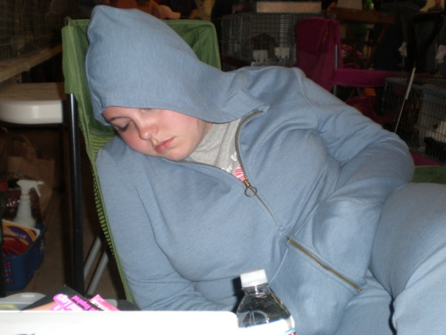

Pay attention to what is going on at the table where your breed will be judged--if judging for mini lops is followed by fuzzy lops, for example, and the judges are picking best of breed mini lop, you know fuzzy lops will be up very soon! Before taking your rabbit to be judged, give him a good grooming. Dampen your hands and work the fur to remove loose hairs, remove static, and add sheen and life to the coat.
Rabbit Show Basics - Part II
Rabbits are always judged in a particular order. For each breed, the judges will judge each variety (color) in alphabetical order and by class. For satins, blacks are first, followed by blues, and so on. Each color is then broken down further into classes. For 4-class animals, you have four--junior and senior bucks and does. Animals that are 6-class have those classes, plus 6/8 or intermediate bucks and does. Senior bucks are judged first, followed by senior does, and then junior (or 6/8) bucks, followed by junior does, and so forth. You have to pay attention as the "ramrod" or guy in charge will yell out "Satins! Black Senior Bucks!" Listen for it and be ready to take your animal up if you have a black senior buck! If you wait too long and the class is judged without you, you are out of luck. The judges usually call out the class being judged several times, so if you didn't hear it the first time, you still have a chance to get your rabbit to the table.
Judging and Evaluation
Each class is judged by itself. For example, all white senior bucks in a breed are shown together and all senior Does are shown together. All rabbits in a class are compared to two "guides" when being judged. First, each animal is evaluated and checked for any disqualifications (DQ) or eliminations. If found, a DQ or elimination will cause the rabbit to be removed from consideration.
All animals in the class are then compared to the breed standard and to each other in groups of gender. The judge will then begin placing them, and when he is satisfied, he begins to call out ear numbers. If there are 10 animals, he starts with tenth place. He then goes to 9th place and on up the line. If your rabbit's ear number is called, remove the animal--his day of showing is done, unless you entered him in another show. Some shows are a double show. This means that there is an A and B show, a morning and afternoon show. When the judge reaches first place, this animal has won Best of Variety (BOV) and is not removed--it is held back, while the Best Opposite sex of Variety (BOSV) leaves the table and is done with that showing.
The first place animals (BOV) in their respective classes will then compete for Best of Group (BOG). They are re-evaluated and the best animal wins the best of that color group. If your rabbit wins, they just earned the Best of Group Status (BOG). The winner is once again held back at the judging table and everyone else is released--their day or show is done.
The rabbit that just won Best of Group (BOG),will be removed to another place on the judging table to await being judged against other winners of their group. It is these animals that will compete for Best of Breed and Best Opposite Sex of Breed (BOB/BOS). The best animal coming closest to the breed standard in the judge's opinion wins BOB and the best animal of the opposite sex wins BOS. The BOS goes home, sometimes with a trophy--and the BOB stays held back again.
After all the breeds have been judged, and the Best of Breeds have been picked for all the breeds, the BOB winners compete once more for the final and most prestigious honor- the Best in Show (BIS) award. The BIS is highly coveted and to win that award is a very difficult challenge. However, if you win, you can earn prize money, a fancy trophy or ribbon or other neat prize and feel pride knowing it was your animal that won out over all the others.
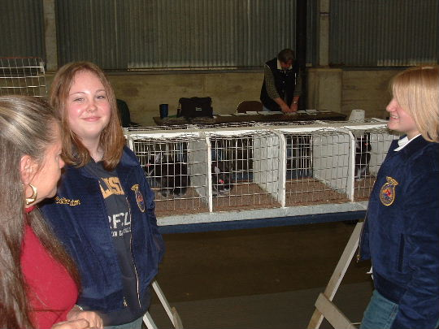
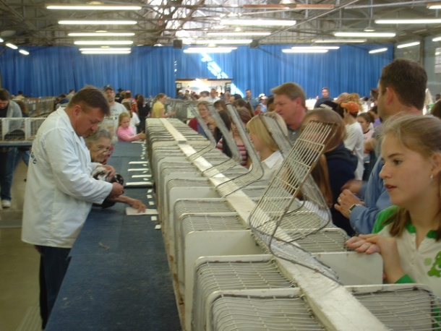
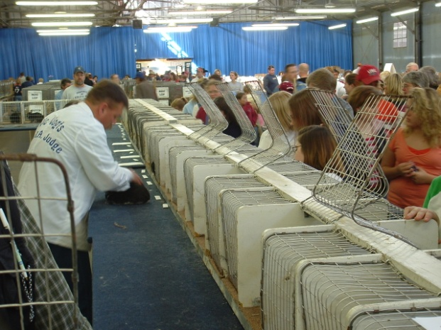

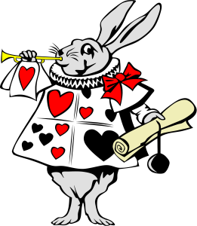

Tips and Show Etiquette
- All exhibitors must be quiet during judging. The writer who records the placements and remarks must be able to hear the judge's comments, and others appreciate hearing without having to strain to hear through rude chatter.
- Do not make any comment about rabbit ownership at the show table--the judge should not know whose rabbit is whose, and neither should anybody else. It's done in the interest of a fair, honest evaluation.
- If you disagree with a judging comment, do not make a scene. Just remember, the judging of a rabbit is based on PERSONAL opinion and what they feel is their interpretation of what the perfect rabbit is to them. What one judge does not like, another might find perfect. You can discuss it calmly and quietly after judging is complete; a judge will be happy to discuss his or her reasoning for the placement. Interfering with a judge by yelling/threatening/etc., is in direct violation of ARBA Show Rule 47, and you can be forced to leave the grounds as well as forfeit all winnings and entries.
- Keep control of your kids and please leave your pets at home. No one appreciates kids running wild and creating chaos. People aren't likely to appreciate having Fido in the showroom, and the rabbits won't like him, either.
- Win, lose, or draw--do it with style and grace. Always be a good sport, and be courteous. Mistakes happen sometimes, and being polite will make things happen much easier (and you will not get a reputation as a hothead, either).
- Read the show rules, and ask one someone such as the show superintendant or the show secretary) if you have any questions. They are there to help you and to run a safe, well-organized show!
- Have a clean carrier and bring all the supplies you need or think you might need. Sani-Wipes are wonderful to bring along. A carrier such as a Pet Taxi is fine, but if the rabbit urinates, it will sit in its own urine and you will have a mess (and a nasty, filthy rabbit). So try to obtain a proper wire rabbit carrier with a pan below to catch the droppings. Having a leaky pan--or, even worse, no pan--is something to be avoided.
- Bring any grooming supplies, grooming tables, towels or whatever you use to prepare your rabbit for judging.
- I also bring a small emergency box with some things that would be useful in case one comes up. The most common item used is the medication that stops bleeding from cutting toe nails. Most people cut toe nails at the show. I do it 2 or 3 days prior to the show.
- If the aisles are narrow, please try not to block them. Tempers can get frayed when people park themselves in the middle of a crowded walkway and block others from getting to their animals or to the judging table in a timely and safe manner.
- Do not--repeat do not--ever bring a sick or diseased animal to a show! Ever! If ever there is a big no-no, this one is it.

Finally, have fun and enjoy yourself!!!!

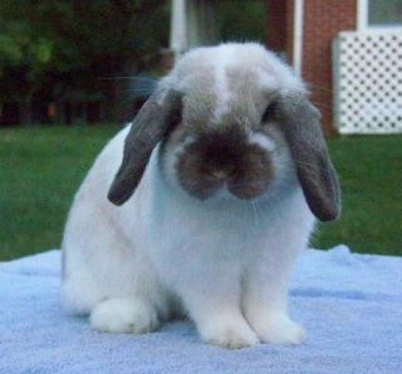

Picking Out a Show Rabbit-Some Basic Tips
- Tell the seller you are looking for a rabbit that you can show - otherwise you may end up with breeding stock!
- Inspect the Rabbit! - thoroughly inspect every rabbit you are interested in - ask an experienced breeder for help if you are not sure how to do this. This is where having The Standard of Perfection really comes in handy.
- Disqualifications - If a judge finds a disqualification on your rabbit, the rabbit is 'DQ'd" and removed from competition. Check carefully for and refuse any rabbit that has disqualifications. Ask the seller if the rabbit has any disqualifications. Some DQs are; malocclusion, split penis, neutered rabbits, wrong colored eyes or toenails for that breed acceptable coat color, missing toenails, broken tail and more (complete list is in the Standard of Perfection).
- Faults - most rabbits have some faults which are usually simple cosmetic or structural defects that don't disqualify the rabbit from competition, but can affect placement in the class. Most breeders are not going to sell you any 'fault-less' rabbits they themselves own, so you will need to choose rabbits that have the fewest faults as possible, or faults that are considered minor for the breed. Again, ask the seller to point out the faults on the rabbit you are interested in.
- For your first show rabbit - choose an adult - this way you will not be surprised by a youngster who grows into an un-showable rabbit!
- Weigh the rabbit - make sure the rabbit is within the breed standard weight as listed in The Standard of Perfection - oversized or overweight does are commonly called 'brood does' and are used for breeding, not showing. Shy away from oversized bucks being sold as 'brood bucks' - oversized bucks are not normally used in breeding programs, especially by inexperienced breeders! If in doubt, ask the breeder to weigh them.
- Just remember- The breeder will not sell you the best of their stock. Be sure to go armed with as much knowledge as you can to get the best animal possible that the breeder has for sale.
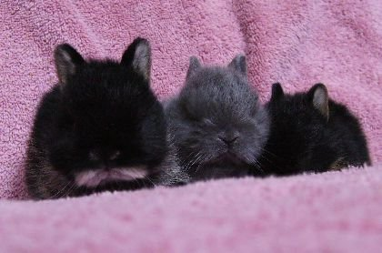

What Kind of Sale Policies Do Breeders Use?
Unfortunately there are no standards for rabbit sales - each breeder has his or her own policies and you, as an interested buyer, should ask the seller about their policies before you decide to buy.
Here are a few commonly-used policies and practices:
1) Unless you personally know the seller, most will require full payment in CASH.
2) If you are buying a pedigreed rabbit, ask for, and expect the pedigree (written 3 or 4 generation ancestry of the rabbit) at the time of sale.
3) Ask for a baggie of the rabbit's current feed so you can transition the rabbit slowly over to your feed.
4) Most breeders will not guarantee your success showing or breeding any rabbit you buy. There are too many factors that can affect showing and breeding, out of the seller's control.
5) Refund and return policies seem to vary widely among breeders - some will never give a refund or allow a return and some will, depending upon the reason. You really need to ask about this and clearly understand what the seller will allow so there are no disappointments.
6) If you decide to buy a young rabbit, keep in mind that most US States don't allow sales of rabbits under 8 weeks of age. Know the law in your state!

How Much Do Show Rabbits Cost?
Pricing varies widely: expect to pay over-inflated prices at any national convention or breed show, oftentimes double what the same rabbit would cost if purchased locally. Very popular and competitive breeds can be locally expensive for good ones - usually between $100-$200 range. Less popular breeds generally run between $20 and $50 a rabbit.
Choose your rabbits carefully - a high price doesn't always mean the rabbit is top show quality! Sometimes breeders just expect more money for their rabbits than they are worth.

Any questions that you may have that was not answered here, please refer to the internet. It has a wealth of information that you can access. Or just attend a show just to observe and you will come away with a lot of information. Breeders and exhibitors both like to talk bunny business.

Winning Standings Chart for a Rabbit Show
Best of Show (BOS)
All Best of Breeds (BOB) of all rabbits go on main table to be judged for the best Rabbit for the entire breed show.
Best of Breed (BOB)
Best of Breed classifies that BOB rabbit as best representation of the standard of perfection of that particular breed. Stays on table to be judged for Best of Show.
Best of Group (BOG)
Remains on table to be judged for Best of Breed
Best of Variety (BOV)
Remains on table to be judged for Best of Group

SHOW TERMINOLOGY
Best in Show (BOS)--A rabbit that stands out by comparison as an excellent representative for the breed. This rabbit came closer to meeting the guidelines of the Standard of Perfection better than any other breed shown at that show
Best of Breed (BOB)--A rabbit that overall has the best type representing the breed by comparison in that breed
Best Opposite Sex of Breed (BOSB) --A rabbit of the opposite sex from the Best of Breed rabbit that displays the best overall type for the breed by comparison in that breed
Best Opposite Sex of Group (BOSG) – A rabbit of the opposite sex from the Best of Group rabbit that displays the best overall in that specific class or color group.
Best of Group (BOG)- The rabbit that displays the best overall of that specific class or color group.
Best Opposite Sex of Variety (BOSV) --A rabbit of the opposite sex from the Best of Variety rabbit that displays the best overall variety. This rabbit, depending on breed, is eligible to compete for Best Of Group.
Best of Variety (BOV) --A rabbit that has won overall for its variety. This rabbit, depending on breed, is eligible to compete for Best of Breed
Legs- When a rabbit wins Best of Group or higher in a show, it earns what is called a winning leg or leg. For every 3 legs that are won, you can obtain from the arba a grand champion certificate. You must be a member of the arba in order to receive this award. Legs are mailed out with final show standing paperwork 2 to 3 weeks after the show.
Broken--A rabbit that has any recognized breed color in combination with white and that carries the breed pattern
Class--Age at which the rabbit is shown: Junior, Intermediate, Senior
DQ (disqualification)--One or more deformities or blemishes that renders the rabbit ineligible for competition and/or registration. (DQ’s can correct themselves. For example, rabbits can be disqualified for a broken tooth, abscesses, under/over weight, ear/fur mites, etc.--all of which are conditions that the rabbit can be treated for to correct the condition.)
Faking--Altering the appearance of the rabbit, such as dying toenails, plucking stray white hairs, etc.
Faults--Imperfections within the breed or variety. A fault is a condition that's not serious enough for a DQ., such as long in type, flat, molting, etc.
Intermediate--A rabbit between six and eight months of age in the heavy weight breeds, known as 6-class animals
Junior--A rabbit under six months of age
Molt--Act or process of shedding or changing fur. A rabbit's baby fur is shed at approximately two months and the first prime coat fur is fully developed at between four to six months of age
Pedigree--A written record of a rabbit's lineage for three generations that contains the rabbit's birthday, variety, and ear number
Registration--The official recording of a rabbit and its pedigree that has been approved by a licensed registrar
Senior--A rabbit over six months of age for 4-class rabbits and over eight months of age for 6-class rabbits
Solid--A rabbit that basically carries the breed color throughout its entire body. This can include selfs, shaded selfs, ticked, wide banded, agouti, pointed whites, etc.
Variety--The color the rabbit is. For example, black, opal, broken, etc.

