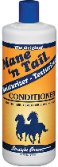
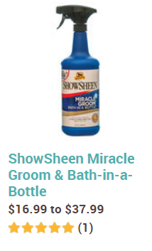
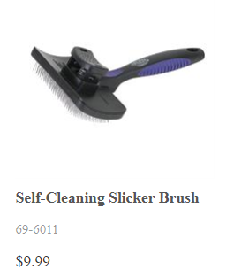
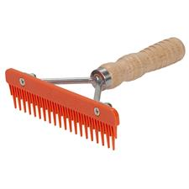
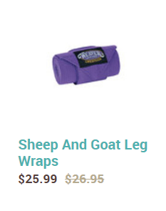
Lamb Leg Shag Care

Supplies Needed:
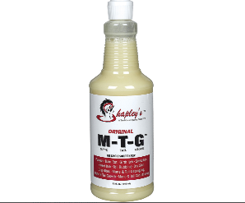
- Dawn Dish Soap
- Wool Comb
  - Self Cleaner Slicker Brush and Mini Fluffer Comb
- Conditioner (Such as Show Sheen)
  - Hair Growth Suggestion
    - Mane and Tail Conditioner
    - M-T-G
      - Mix together and water down
- Leg Wrap
  - Wrap Style or Sock Style with Velcro Strap
  - Facebook Page: Shag Rags
  - Must be very careful to not put too tight!!!
- Blower
- Lamb Stand

Instructions:
**Recommended 2 times a week (3-4 days in between)
- With your lamb on the stand, wash their leg wool only with dawn dish soap and rinse well
  - 2” above the knees and up to the hocks
- Blow out the excess water (Dry)
- Spray with Conditioner
- Brush shag in a straight, downward motion
- Keep the blower about 2 feet away from the leg and blow dry conditioner towards the skin
- Brush shag in a straight, downward motion
- Wrap legs to keep clean and keep a muzzle on your lamb at all times
  - Keep an eye on your lamb’s legs to make sure the wrap is not too tight

